Dear Parent/Carer,

Access to the Read Write Inc. Phonics eBook Library at home

At school, your child is learning to read with Read Write Inc. Phonics, a very popular and successful literacy programme published by Oxford University Press.
We will be using an online eBook library to set your child reading practice to do at home each week.
Your child will be given a username and a password so that they can access their own personal student area on OxfordOwl.co.uk. Once they have logged in, your child can complete their homework by going to the homework tab:
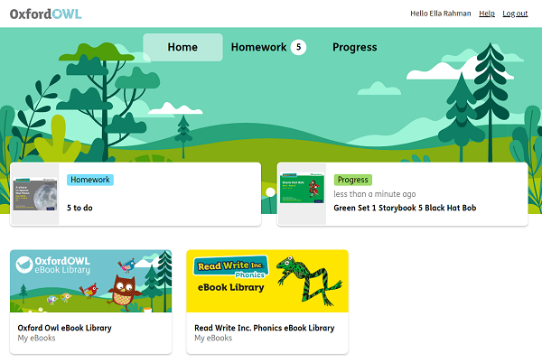
In the homework area, your child will find an eBook which has been assigned to them to read. Your child will already have read this story three times in class with their reading teacher, so they should be able to read the story confidently.
How to listen to your child read the eBook
- Do not read the eBook aloud before your child reads it to you.
- Ask your child to read the sounds and words at the start of the eBook before they read the story. (The Sound Blending books do not contain these.)
- When your child reads the story, ask them to sound out any words that they can’t read easily. Don’t allow your child to struggle too much and praise your child when they succeed.
- Read back each sentence or page to keep the plot moving. (Your child’s energy is going into reading the words, not following the story.)
- Do not ask your child to guess a word by using the pictures.
- Do it all with patience and encouragement!

When your child has read the set eBook, they can let their teacher know that they have completed it, and what they thought of it:
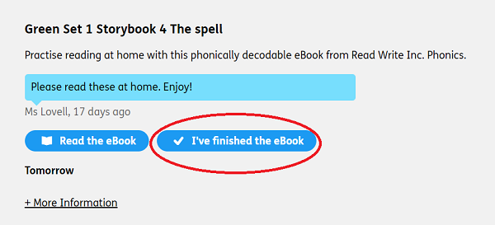
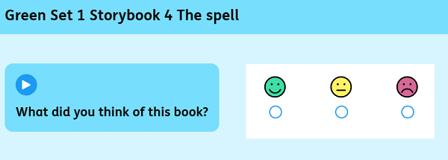

Your child can re-read any of their previous eBooks at any time by clicking on Fred Frog:
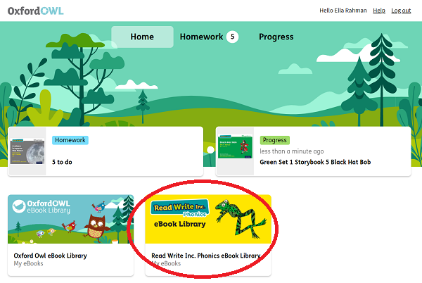
If you need further support using the eBook Library, please visit the Student Support page
Yours sincerely,
Holly Booth

