
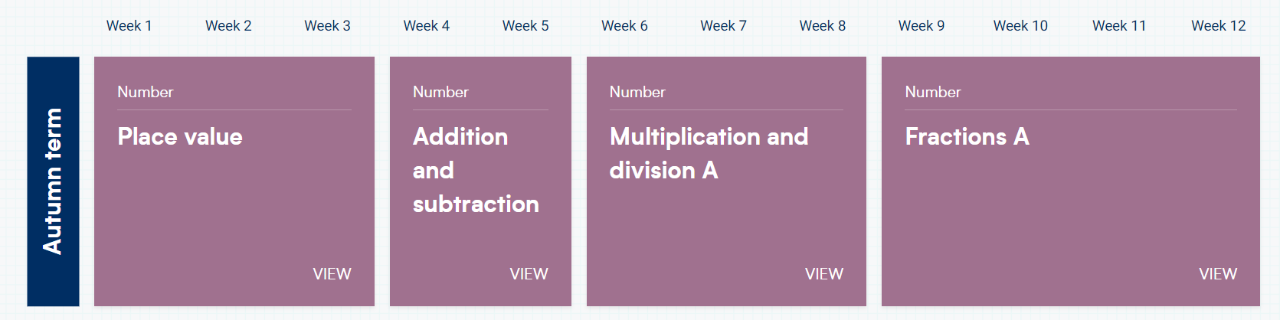
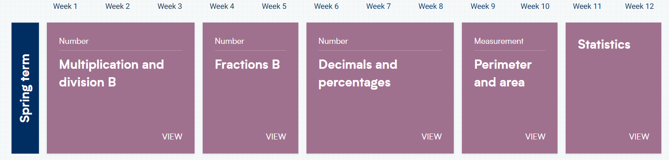
White Rose Maths Scheme of Learning – Year 5

