
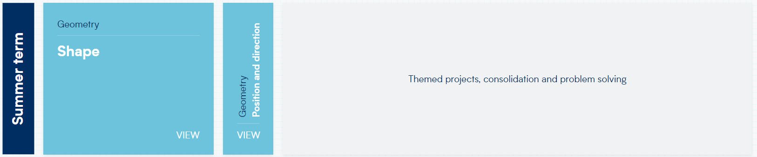
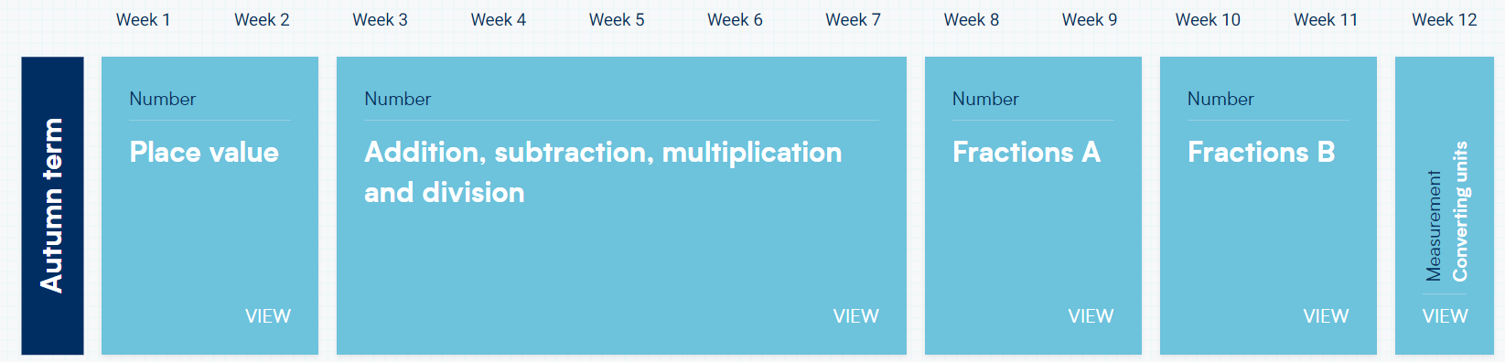
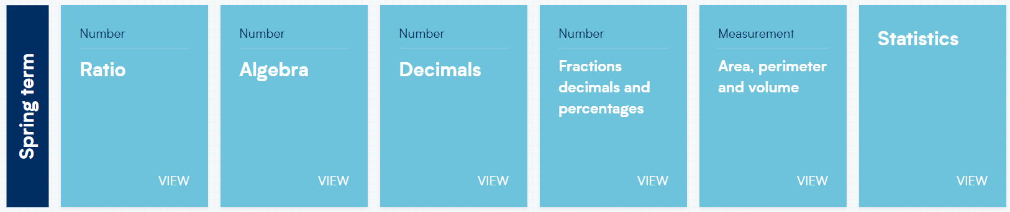
White Rose Maths Scheme of Learning – Year 6

